**Technical design**

**Single Sign On**

**Version 1.0**

|  |  |  |
| --- | --- | --- |
| Project | : | [Sitecore](https://eportal.exact.nl/docs/PRProjectDossier.asp?FromView=1&ProjectNr=MTPRODMAN.009.006) test |
| Author | : | [Stephen Chong](https://eportal.exact.nl/docs/EPEmployeeDossier.asp?ID=28591) |
|  | : |  |
| Date last modified | : | Wednesday, 01 May, 2018 |

# Modification register

The following changes have been made since the first version of technical design.

|  |  |  |  |  |
| --- | --- | --- | --- | --- |
| **Date** | **Version** | **Chapter** | **Modified by** | **Remarks** |
| 01-05-2018 | 1.0 | **r**Initial design | Stephen Chong | **r**Initial design |

## 

# System overview

This technical document describes the concept and technical spec on how the Single Sign On service can work on cross domain websites. The application is using form authentication process which permits a user to enter username and password in order to access or switch to other web application.

Web Service (REST)

Home Account

Web client

Database

SSO BackOffice

Client

# Sequence Diagram

### Form Authentication – SSO BackOffice

.NET Runtime

Login

Authenticated

Browser

Request to authenticated page

Check authentication cookie

Cookie available – Execute authenticated page

Verify user and load user

Cookie unavailable – redirect to login page

Response

### Form Authentication - Client

.NET Runtime

Login

Authenticated

Browser

Check authentication cookie

Request to authenticated page

Verify user by userID via API over sessiontimeout

Cookie available & user found– Execute authenticated page

Load user

Cookie unavailable & user not found – redirect to login page

Response

# Database Model

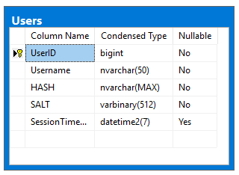

## Components Model

## Object Model

## Impact Analysis